Protocol Template for the Evaluation of Domain Match and Feasibility of XXXX for Use in Core Outcome Sets for XXXX

PURPOSE & SCOPE
Before advancing an instrument to a full psychometric measurement-property evaluation (via systematic literature review (SLR)), OMERACT recommends first assessing two foundational characteristics of a candidate instrument, as specified in the OMERACT Filter Instrument Selection Algorithm (OFISA) ¹:
- Domain Match – Does the instrument’s content align with, and adequately cover, the endorsed domain definition? ^{3,4}
- Feasibility – Is the instrument practical to implement (burden, access, costs, training, administration)?
This protocol outlines a two-stage evaluation process:
- Stage 1 (Steering Group Deep Dive): A detailed review of question-level domain match and feasibility by the working group steering committee and selected PRPs.
- Stage 2 (Broader Group Review & Consensus): A high-level review of overall domain match and feasibility by the wider OMERACT community, informed by Stage 1 findings.
This early screen helps ensure that only instruments with acceptable domain coverage and feasibility advance to the more resource-intensive SLR stage.

Note on Construct Validity: At this stage, working groups may incorporate hypothesis-driven construct validity checks into their surveys. However, this is optional and not required to complete the Domain Match & Feasibility step.

RATIONALE:
Selecting an instrument to move to a psychometric measurement-property evaluation (via SLR) requires that it measures the target domain and is feasible to use. This protocol outlines the OMERACT methodology for assessing domain match and feasibility, building on frameworks for sensibility and concept match developed in the measurement literature. The two-stage approach balances efficiency with inclusivity by first allowing a smaller expert group to conduct a detailed review, which minimizes the burden on the broader community. In the second stage, the process ensures transparency and consensus by integrating perspectives from PRPs and other collaborators across OMERACT.
Key Sources Informing This Approach
Pakulis PJ et al. ⁴, 2005; Smith ML et al. ⁵, 2010; *Wells G et al. ⁶, 2014; Auger C et al. ⁷, 2006; Terwee CB et al. ⁸, 2010; Lawshe CH, 1975 ⁹; Rowe BH & Oxman AD, 1993 ¹⁰; Feinstein AR, 1987 ¹¹; *Tang K et al., 2013 ¹²; Law M, 1987 ¹³; Nunnally & Bernstein, 1994 ¹⁴. (See full citations in References; *OMERACT review/synthesis papers)

RESEARCH QUESTIONS
- Domain Match: How well does [INSTRUMENT NAME, VERSION] capture the relevant issues of [DOMAIN] in patients with [DISEASE]?
- Feasibility: How feasible is [INSTRUMENT NAME, VERSION] to use in clinical trials for [DISEASE], as considered by PRPs and other OMERACT collaborators?
Optional
- Construct validity: To what extent does [INSTRUMENT NAME, VERSION] show expected relationships with related constructs?

OBJECTIVES
This study aims to:
- Stage 1 (Steering Group Deep Dive):
- Assess question-level content match, clarity, and comprehensiveness of [INSTRUMENT NAME & VERSION].
- Evaluate feasibility in detail (completion time, missing data, clarity, administration, cultural/linguistic appropriateness).
- Generate an initial traffic-light rating (Green/Amber/Red) with rationale.
- Stage 2 (Broader Group Review & Consensus):
- Present Stage 1 findings to the broader OMERACT group.
- Seek high-level endorsement on domain match and feasibility.
- Achieve consensus using OMERACT thresholds before advancing to SLR.
Optional
- Explore construct validity through pre-specified hypotheses and correlations with other instruments included in the survey.

DESIGN
This study will use a two-stage cross-sectional survey and consensus process involving two participant groups (see Figure 1):
- Stage 1 (Steering Group Deep Dive):
- Participants: Steering group members, including PRPs, and invited content experts.
- Focus: Item-level analysis (domain match, redundancy, clarity), feasibility (burden, cost, access, training).
- Methods:
  - Item-level ratings (Yes/No/Uncertain).
  - Quantitative analysis of PRP responses (response distributions, missing data, Cronbach’s alpha, item–total correlations).
  - Qualitative feedback on gaps, clarity, and feasibility barriers.
- Output: Detailed evidence summary and draft traffic-light rating.
- Stage 2 (Broader Group Review & Consensus):
- Participants: Wider OMERACT community (≥30 PRPs; ≥30 clinicians, researchers, policymakers, payors, industry).
- Focus: Overall assessment of whether the instrument matches the domain and is feasible in practice.
- Methods:
  - Presentation of Stage 1 findings.
  - High-level survey (overall domain match, overall feasibility, 0–10 scales, Yes/No/Uncertain items).
  - Consensus process using OMERACT endorsement thresholds.
- Output: Final traffic-light rating (Green/Amber/Red) and decision whether the instrument advances to SLR.
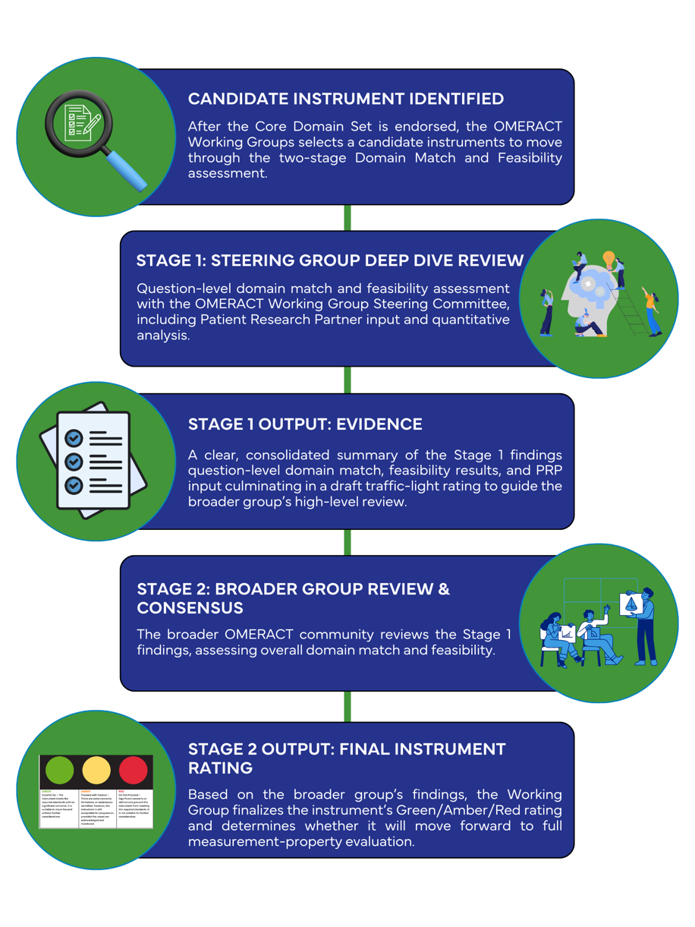
Figure 1: Two-Stage Process for Evaluating Domain Match & Feasibility

PARTICIPANTS
Stage 1 (Steering Group & PRPs):
- PRPs with lived experience.
- Steering group members (clinicians, researchers, methodologists).
- Optional content experts.

Stage 2 (Broader Group):
- ≥60 participants total, with ≥30 PRPs and ≥30 other collaborators.
- Representation from all OMERACT collaborator groups.
Sample size rationale: While no formula exists for domain match/feasibility surveys, n≈30 per group provides diverse perspectives and stable descriptive summaries to inform Working Group decision-making.
Inclusion
- PRPs
- ≥18 years
- lived experience of [DISEASE]
- completed/willing to complete the OMERACT e-learning module on Instrument Selection
- implied consent via survey entry.

- Other Collaborators
- ≥18 years;
- engaged in OMERACT core outcome set work (researcher, provider, policymaker, payor, industry)
- completed/willing to complete OMER-ED e-learning module
- implied consent via survey entry.
Exclusion (either group): Unable/unwilling to complete the survey in the available language(s)/mode(s).

RECRUITMENT & CONSENT
Recruit via OMERACT mailing lists and Working Group channels using approved electronic/paper postcards with URL/QR. A brief eligibility screen precedes the survey.
Consent: An information page precedes the survey; proceeding indicates implied consent. Participation is voluntary and anonymous.

CONFIDENTIALITY
No personally identifying information will be collected. Responses are anonymous, stored with study IDs only; IP and email are not retained. Aggregate reporting only; categories with <5 respondents will be combined or suppressed.

SURVEY ADMINISTRATION
Platform: [Platform name] hosted on [Server location/provider].
Versions: Tailored for Stage 1 vs Stage 2 groups and PRP survey vs. Other Collaborators.
Fielding: Two weeks, with reminders at midpoint and 24h before close.

Data Management & Analysis
All data will be collected through a secure online survey platform. Upon survey completion, data will be reviewed to ensure no retention of identifying information, such as IP addresses, before being downloaded in CSV format. Data files will be securely stored on an institutional server, with access restricted to the study team to maintain confidentiality and data integrity.

Consensus Criteria:
- An instrument is endorsed for Domain Match and Feasibility when collaborator groups (PRPs and Other Collaborators) have ≥70% Yes.
- If the difference in endorsement rates between collaborator groups is ≤10%, and the combined average remains ≥70%, the instrument will be considered agreed upon.
- If the collaborator group difference is >10 points, classify the item as dissensus and flag for Working Group discussion, regardless of the combined rate.
Sample & Scale Description
Descriptive statistics will be used to describe the sample demographics (age, gender, etc.) for both groups: PRPs and all other collaborators. The distribution of the instrument, as completed by the PRP group, will be used to describe the range of scores.

Final decision about the instrument.
The results of the domain match and feasibility assessment will be presented to the working group steering committee for evaluation. Based on the findings, the group will determine whether the instrument is suitable for further consideration using a traffic light rating system:
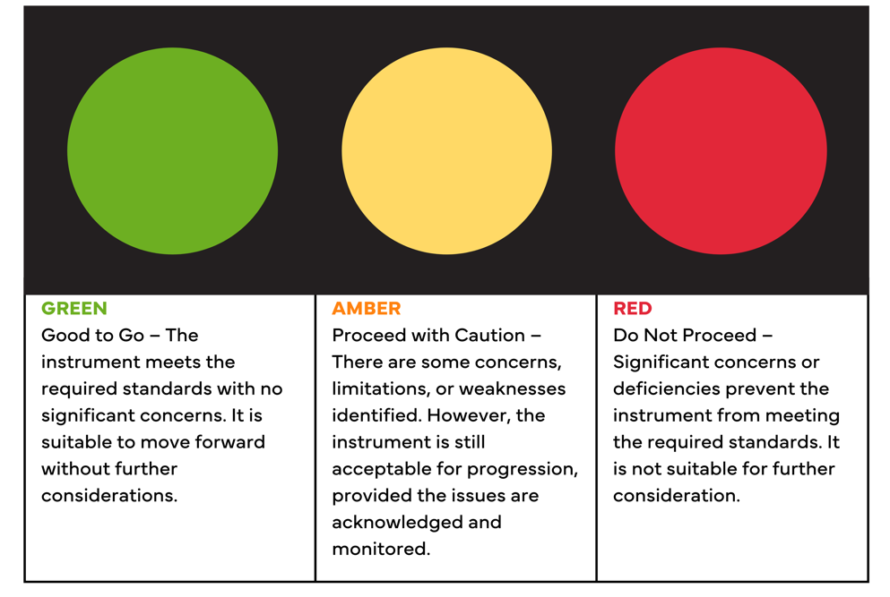
Figure 2. Meaning of the traffic light scoring in the instrument selection part A domain match & feasibility
Only instruments receiving a Green or Amber rating will advance to a full evaluation of measurement properties.

CONSTRUCT VALIDITY (OPTIONAL)
Groups may include construct validity items (e.g., correlations with global health, known groups) if it aligns with their work plan and resources. This allows flexibility—groups with the capacity to gather early insights on construct validity can do so.
To evaluate construct validity, additional items will be included to examine expected correlations between the candidate instrument and related constructs. Anticipated relationships will be pre-specified before survey administration.
- Construct validity will be tested by comparing instrument scores with constructs fielded in the survey for comparison.
- A priori hypotheses for each comparison, including expected direction and magnitude, will be documented in the OMERACT construct validity narrative table (sample shown below).
- Concurrent comparison of two instruments will be carried out using the Spearman rank correlation coefficient, which can be used with ordinal data.
- Known group comparisons will be tested using an unpaired analysis of variance, with statistical significance set at p < 0.05.
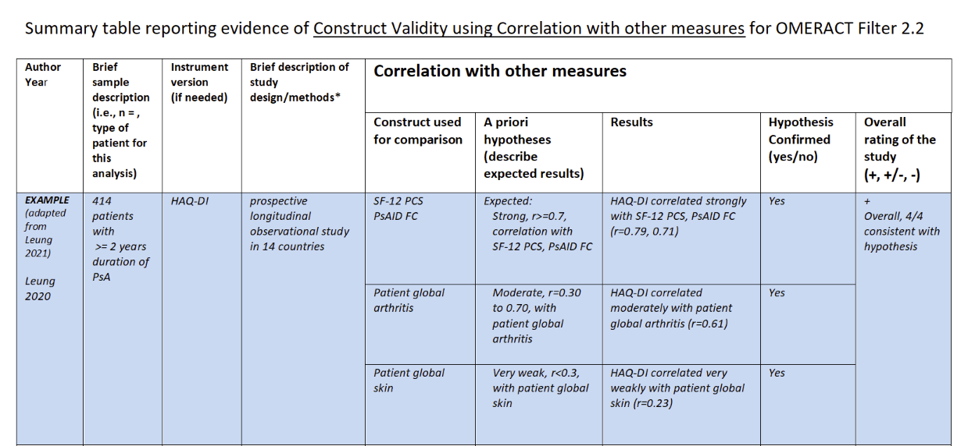
Figure 1: Sample summary table reporting evidence of construct validity using correlation with other measures for OMERACT Filter 2.2

References
1. Beaton D, Boers M, Maxwell L, et al. Evidence-Based Decision Making For The Selection Of Instruments For Core Outcome Sets: Part A & B. In: Beaton D, Bingham CI, Boers M, et al., eds. The OMERACT Handbook . 2.3.
2. D’Agostino MA, Beaton DE, Maxwell LJ, et al. Improving domain definition and outcome instrument selection: Lessons learned for OMERACT from imaging. Semin Arthritis Rheum. 2021;51(5):1125-1133. doi:10.1016/j.semarthrit.2021.08.004
3. Maxwell LJ, Jones C, Bingham CO, et al. Defining domains: developing consensus-based definitions for foundational domains in OMERACT core outcome sets. Semin Arthritis Rheum. 2024;66. doi:10.1016/j.semarthrit.2024.152423
4. Pakulis PJ, Young NL, Davis AM. Evaluating physical function in an adolescent bone tumor population. Pediatr Blood Cancer. 2005;45(5):635-643. doi:10.1002/pbc.20383
5. Smith ML, Sosa ET, Tisone CA, et al. Quality Enhancement Groups: A Qualitative Research Method for Survey Instrument Development. Vol 1.; 2010. https://www.researchgate.net/publication/266573781
6. Wells G, Beaton DE, Tugwell P, et al. Updating the OMERACT filter: discrimination and feasibility. Journal of rheumatology. 2014;41(5):1005-1010. doi:10.3899/jrheum.131311
7. Auger C, Demers L, Swaine B. Making sense of pragmatic criteria for the selection of geriatric rehabilitation measurement tools. Arch Gerontol Geriatr. 2006;43(1):65-83. doi:10.1016/j.archger.2005.09.004
8. Terwee CB, Mokkink LB, van Poppel MNM, Chinapaw MJM, van Mechelen W, de Vet HCW. Qualitative Attributes and Measurement Properties of Physical Activity Questionnaires: A Checklist. Sports medicine (Auckland). 2010;40(7):525-537. doi:10.2165/11531370-000000000-00000
9. LAWSHE CH. A QUANTITATIVE APPROACH TO CONTENT VALIDITY 1. Pers Psychol. 1975;28(4):563-575. doi:10.1111/j.1744-6570.1975.tb01393.x
10. Rowe BH, Oxman AD. An assessment of the sensibility of a quality-of-life instrument. Am J Emerg Med. 1993;11(4):374-380. doi:10.1016/0735-6757(93)90171-7
11. Feinstein AR. Clinimetrics. Yale University Press; 1987.
12. Tang K, Beaton DE, Lacaille D, Gignac MAM, Bombardier C. Sensibility of five at-work productivity measures was endorsed by patients with osteoarthritis or rheumatoid arthritis. J Clin Epidemiol. 2013;66(5):546-556. doi:10.1016/j.jclinepi.2012.12.009
13. Law M. Measurement in Occupational Therapy: Scientific Criteria for Evaluation. Canadian journal of occupational therapy (1939). 1987;54(3):133-138. doi:10.1177/000841748705400308
14. ten Berge JMF. J. C. Nunnally and I. H. Bernstein. Psychometric Theory. New York: McGraw-Hill, 1994, xxiv+752 pages, £51.95. Psychometrika. 1995;60(2):313-315. doi:10.1007/BF02301419

Appendix. A – Survey for Steering Group Members: Evaluating Domain Match and Feasibility of Instruments to Measure the Core Domain Set in XXX
PAGE 1: Introduction:
Thank you for taking the time to complete this survey for the OMERACT XXX Working Group.
Why This Step is Important:
The first step in the OMERACT Instrument Selection Process is to assess domain match and feasibility:
- Domain match: Does the instrument measure the core domain and it's detailed definition that was endorsed as critical to measure in every clinical trial.
- Feasibility: Can the instrument be used in the intended setting? (e.g., practical, affordable, and implementable)?
Even a scientifically strong instrument has limited value if it does not measure the core domain or if it cannot be used in practice. Addressing these questions early helps avoid problems later and ensures only the most suitable instruments move forward.
What to Expect
1. Review the endorsed domain definition and ensure you’re clear on what we agreed needs to be measured.
2. Complete each candidate instrument, considering how well it captures the target domain.
3. Rate the instrument by answering questions on domain match and feasibility.
Your Role
Please draw on your professional expertise and experience when completing the survey. Your input will help us determine whether the instrument both reflects the agreed-upon core domain and is practical for use in the intended setting.
Thank you for your contribution—we look forward to your insights!

PAGE 2: DEMOGRAPHIC QUESTIONS
- Country of Residence (WHO Dropdown)
- Please select the collaborator group that best represents your affiliation or role in relation to your involvement with OMERACT.
Principal investigators
Provider
Payers and purchasers of health services
Policymakers
Program managers
Payers/funders of research
Publishers
Product makers such as pharmaceuticals, medical devices, and diagnostics
Public
Producers and commissioners of guidelines

PAGE 3: Core Domain XXX
Our working group has agreed on a definition of XXX, and it has been formally endorsed as XXXX. You can review the full domain definition report [here]. Please keep this definition in mind as you evaluate whether the instrument captures the core domain XXX.
The instrument we’d like you to review is called XXX. Please complete it, reflecting on your experience of patients with XXX.
After you complete it, we’ll ask you a few short questions about what you thought of the instrument.
Assessment on Instrument Domain Match: Thinking about the content of the questions/items in the instrument XXX, based on your experience with XXX.
Questions: Instructions: Instructions: For each criterion below, mark “Yes,” “Uncertain,” or “No,” and provide any comments about your choice. | Answer Options
Does this instrument adequately capture the intended core domain as defined by our working group? | Yes/No/Uncertain
Does the instrument include all important elements of the domain, with sufficient breadth (range of aspects) and depth (level of detail) for this population and intended application? | Yes/No/Uncertain
Is the instrument free of redundant, unnecessary, or potentially inappropriate, or sensitive items? | Yes/No/Uncertain
Are the items written in plain, clear, and understandable language for the target population? If technical terms are used, is a glossary provided to support completion? | Yes/No/Uncertain
Are the instructions for completing questions (items) and selecting responses clear enough that the instrument could be completed without assistance? | Yes/No/Uncertain
Are the response options (e.g., scale anchors, ordering) clear, appropriate for each question, and able to capture meaningful differences between responses? | Yes/No/Uncertain
Is the recall period (e.g., past week, last 24 hours) appropriate for the domain, the target population, and the intended application? | Yes/No/Uncertain
Is the method of scoring (e.g., use of weighting, composite scores, handling of missing data) transparent, replicable, and appropriate for the domain? | Yes/No/Uncertain
Comments:
Overall, how well does this instrument capture the intended core domain of XXX? (sliding scale 0-10) | Left - 0 = Not at all – The instrument does not capture the domain.  Centre -5 = Partially – The instrument captures some but not all important aspects of the domain.  Right - 10 = Extremely well – The instrument fully and clearly captures the domain as defined

Assessment on Instrument Feasibility: Questions about the practical considerations of instrument XXX
Questions: Instructions: For each criterion below, mark “Yes,” “Uncertain,” or “No,” and provide any comments about your choice. | Answer Options
Is this instrument easy for the intended target population to complete? | Yes/No/Uncertain
The instrument developers suggested it should take about 10 minutes to complete. How did your experience compare? a reasonable amount | Yes/No/Uncertain
Is the layout of the instrument (e.g., font size, spacing, order of items, page/webpage design) appropriate and user-friendly? | Yes/No/Uncertain
Does the instrument require minimal equipment, training, or special expertise to administer? | Yes/No/Uncertain
Is the method of administration (e.g., paper form, computer-based, mobile device, special equipment) feasible for the intended context?  Are the costs feasible? (consider licensing fees, equipment and training costs). | Yes/No/Uncertain
Comments:
Overall, how feasible is this instrument for use in the intended setting? (sliding scale 0-10) | Left - 0 = Not feasible at all – The instrument would be very difficult or unrealistic to implement in the intended.  Centre -5 = Moderately feasible – The instrument could be implemented, but with notable challenges (e.g., cost, time, training, burden).  Right - 10 = Extremely feasible – The instrument is straightforward, feasible, and efficient to implement in the intended.
Is there anything else you want to tell us about instrument XXX? | (comment box)

NOTE: A draft version of the PRP survey has been created in SurveyMonkey. OMERACT can customize this survey so that multiple instruments or domains can be included and completed at the same time. If your working group would like to use this option, please contact admin@omeract.org to request a custom link. You can view the draft survey here: https://www.surveymonkey.ca/r/DMF_SC

Appendix. B – Stage 2 Survey Of Broader OMERACT Community Evaluating Domain Match & Feasibility of [INSTRUMENT XXX]
PAGE 1: Introduction:
Thank you for taking the time to complete this survey for the OMERACT XXX Working Group.
We are now at the next step of reviewing the instrument [INSTRUMENT XXX]. A small team (the Steering Group) has already done a detailed, “deep dive” review. In this survey, we’re asking for your high-level feedback on their summary findings, not for you to complete the instrument.
- Domain Match: Does the instrument, as shown in the Stage 1 summary, measure the core domain we agreed is important?
- Feasibility: Can the instrument, as shown in the Stage 1 summary, be used in the intended setting (is it practical, affordable, and realistic)?
You don’t need to complete the instrument or comment on every individual question. Please review the Stage 1 summary and answer the high-level questions below. Your input will help the Working Group confirm consensus before the instrument moves on to a full evidence review.
Thank you for sharing your experience — your perspective is essential.

PAGE 2: DEMOGRAPHIC QUESTIONS
- Which terms best describe your current gender identity? Please select the option(s) that apply to you.

- Agender
- Bigender / multigender
- Genderfluid
- Genderqueer
- Man
- Non-binary
- Questioning
- Transgender
- Two-spirit
- Woman
- I prefer not to answer
- A gender not specified above. I identify as: (please specify:)

- Please select your age range

- Under 18
- 18–34
- 35–54
- 55–64
- 65 or older

- What language do you usually speak at home?
- English
- French
- Other (please specify)
- Country of Residence (WHO Dropdown)
- What is your role (in OMERACT)?

- Patient Research Partner
- Principal investigators
- Provider
- Payers and purchasers of health services
- Policymakers
- Program managers
- Payers/funders of research
- Publishers
- Product makers such as pharmaceuticals, medical devices, and diagnostics
- Public

PAGE 3: Review Materials
We have prepared a one-page summary of the Stage 1 findings, including:
- Key strengths and gaps identified in how well the instrument matches the domain.
- Key feasibility considerations (burden, costs, administration).
- The draft traffic-light rating given by the Steering Group.
Please read the summary before answering the questions. [SUMMARY]
Assessment on Instrument Domain Match: Thinking about the Stage 1 summary of the instrument provided by the working group to measure XXX, based on your experience with XXX:
Questions: Instructions: For each criterion below, mark “Yes,” “Uncertain,” or “No,” and provide any comments about your choice. | Answer Options
Based on the Stage 1 findings, do you agree that this instrument adequately captures the intended core domain as defined by our working group?  Comments: | Yes/No/Uncertain
Do you agree that the instrument includes all important elements of the domain at an appropriate breadth and depth for this population and application?  Comments: | Yes/No/Uncertain
Overall, how well does this instrument capture the intended core domain of XXX? (sliding scale 0-10) | 0 = Not at all – The instrument does not capture the domain.  5 = Partially – The instrument captures some but not all important aspects of the domain.  10 = Extremely well – The instrument fully and clearly captures the domain as defined

Assessment on Instrument Feasibility: Questions about the practical considerations of instrument XXX
Questions: Instructions: For each criterion below, mark “Yes,” “Uncertain,” or “No,” and provide any comments about your choice. | Answer Options
Based on the Stage 1 findings, do you agree that the instrument is practical and feasible for use in the intended setting (cost, time, training, burden)?  Comments: | Yes/No/Uncertain
Overall, how feasible is this instrument for use in the intended setting? (sliding scale 0-10) | Left - 0 = Not feasible at all – The instrument would be very difficult or unrealistic to implement in the intended.  Centre -5 = Moderately feasible – The instrument could be implemented, but with notable challenges (e.g., cost, time, training, burden).  Right - 10 = Extremely feasible – The instrument is straightforward, feasible, and efficient to implement in the intended.

Final Endorsement
- Do you endorse advancing this instrument to a systematic literature review for full measurement-property evaluation? Yes / No / Uncertain
- If No or Uncertain, please briefly state why (e.g., key concerns about domain match or feasibility): (open text)
- Any other comments or suggestions regarding this instrument: (open text)

NOTE: A draft version of the survey has been created in SurveyMonkey. OMERACT can customize this survey so that multiple instruments or domains can be included and completed at the same time. If your working group would like to use this option, please contact admin@omeract.org to request a custom link. You can view the draft survey here: https://www.surveymonkey.ca/r/DMF_Other

