**DELPHI SURVEY TO SEEK CONSENSUS ON DOMAINS TO BE INCLUDED IN THE OMERACT [XXX] CORE DOMAIN SET.**

|  |  |
| --- | --- |
| OMERACT Working Group: |  |
| Name: |  |
| E-Mail |  |
| Phone |  |
| Institution |  |
| Address |  |

**INTRODUCTION & RATIONALE**

OMERACT is a global, volunteer-driven, not-for-profit organization committed to improving outcomes for patients with autoimmune and musculoskeletal diseases through advancing the design and quality of clinical studies.

Through rigorous methodology and global Working Groups, OMERACT supports the development of Core Outcome Sets (COS), identifying patient and disease-relevant areas to be measured (domains) and the corresponding instruments for use in clinical trials, including those for regulatory approval of new treatments.

OMERACT seeks to standardize what is measured (domains), and how it is to be measured (instruments) in all clinical research within a defined area. OMERACT methods are based on inclusiveness, collaboration, and consensus. Working group leaders are the core decision makers and seek endorsement of their decisions through the OMERACT community. Working Groups follow OMERACT methods for Core Domain Set development. Once the domains are endorsed, they work on identifying instruments that measure each core domain to form a Core Outcome Set. When selecting domains for a Core Domain Set (CDS), input is needed from collaborator groups. At OMERACT, we believe patient research partners (PRPs) are essential to understanding core domains, though their opinions can be hard to “see” in a large survey. OMERACT, therefore, stratifies the domain selection process into the opinion of those with lived experience of the disease (patient research partners) and the group representing all other collaborators (Payers and purchasers of health services, Payers/funders of research, Policymakers, Principal Investigators, Producers and commissioners of guidelines, Product Makers, Program managers, Providers, the Public, and Publishers.

OMERACT recommends using the Delphi Technique to reach a consensus on domains to be included in CDSs. Delphi surveys can be a beneficial research methodology when there is no true or knowable answer and when seeking consensus and input across a large group of collaborators. A wide range of opinions can be included, which can be useful in cases where relying on a single expert would lead to bias. Key reasons OMERACT recommends conducting a Delphi rather than other consensus methods in Core Domain Set development are:

* Face-to-face interaction is difficult due to large & international sample sizes.
* Anonymity is preferred.
* A chance of domination of a group discussion by one person.
* Generation of group decisions that represent the opinions of all collaborators.
* Individuals can examine other answers from all collaborators and change their minds.

**CONSTRUCTING THE DELPHI SURVEY**

***Constructing Delphi Survey – Software***

OMERACT recommends the use of Delphi-specific survey software. This software supports the prioritization of domains for a CDS and facilitates decision-making among a diverse group of collaborators. The chosen software should allow for easy administration of the survey across multiple rounds, maintaining the anonymity of participants while providing structured feedback.

Key Features of the Delphi Software include:

* **Anonymity:** Ensures that responses remain anonymous, reducing potential bias and preventing dominant voices from influencing the group's consensus.
* **Feedback Mechanism:** Allows participants to view aggregated feedback from other participants between rounds, promoting reflection and enabling them to adjust their responses based on the collective input.
* **Data Collection and Analysis:** Automates the collection of quantitative and qualitative data from survey rounds, offering tools to analyze trends and levels of consensus across different rounds.
* **Customization:** Supports the customization of survey content to fit the specific needs of each working group, including the flexibility to adjust domains and criteria based on feedback and evolving consensus.

***Constructing Delphi Survey – Domains***

Domains were generated through qualitative research and literature reviews, resulting in [XXX] domains spanning all OMERACT Core Areas. Each domain was carefully defined for clarity. The domain generation process involves refining the detailed information gathered during the generation stage into candidate domains. This requires two key steps: “binning” and “winnowing.” OMERACT advises that up to 30 candidate domains be included in the Delphi survey to narrow down to 5-7 core domains. The Domain Definition Tracker documents the final [XXX] domains, their definitions, and classifications (e.g., core area, symptom, sign, or biomarker) (Appendix A).

***Constructing Delphi Survey –Consensus Criteria for Delphi Survey***

Consensus agreement is defined by over 70% of both collaborator groups (Patient Research Partners and All Other Collaborators) voting that the domain is critically important to include (scoring 7 to 9 on the 1 to 9 scale) or not important to include in the Core Domain Set being developed (scoring 1 to 3) over a minimum of two rounds of the Delphi. Once a candidate domain has reached this level in two rounds, it will be considered as having reached a consensus for inclusion or exclusion. A consensus by one group but not both groups will be considered important, but there will not be a full consensus. These candidate domains may be worth inclusion as optional domains or ones requiring further research and discussion. Domains that reach consensus levels in Rounds 1 and 2 (for either inclusion or exclusion) will not be presented in Round 3 for voting; however, they will be presented as the list of domains where consensus has been reached.

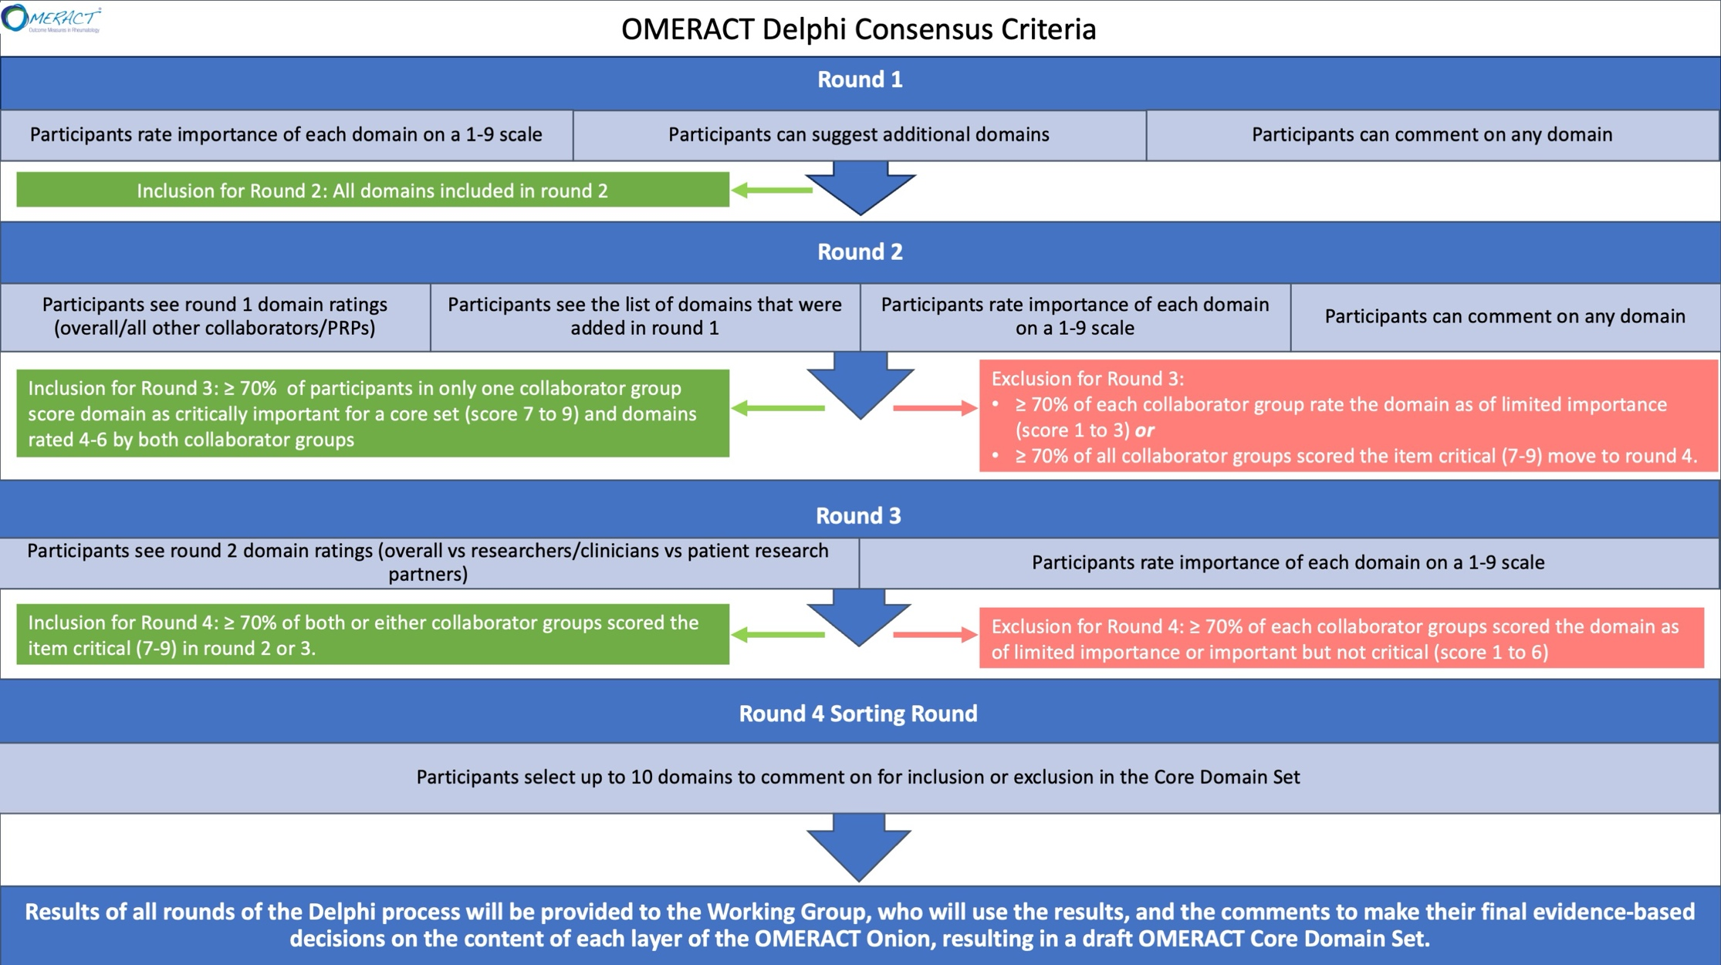

***Constructing Delphi Survey – Rounds***

OMERACT recommends four Delphi rounds to ensure a thorough and structured process for selecting domains in developing a CDS for a particular health condition. The first three rounds are a Delphi Survey to rate the importance of the domains for inclusion in the Core Domain Set in this area. While OMERACT recommends this four-round structure, working groups must decide whether to set the total number of rounds a priori or adapt based on the results. If the number of rounds is not determined in advance, criteria such as stability in responses, consensus achievement, or diminishing returns from additional rounds should guide the decision to end the survey.

**Rounds 1 to 3:** These initial rounds focus on evaluating the importance of each domain for inclusion in the draft CDS. Participants rate the relevance of domains using a standardized rating scale (Figure 2), which helps determine the priority of domains based on feedback from a broad range of collaborators.

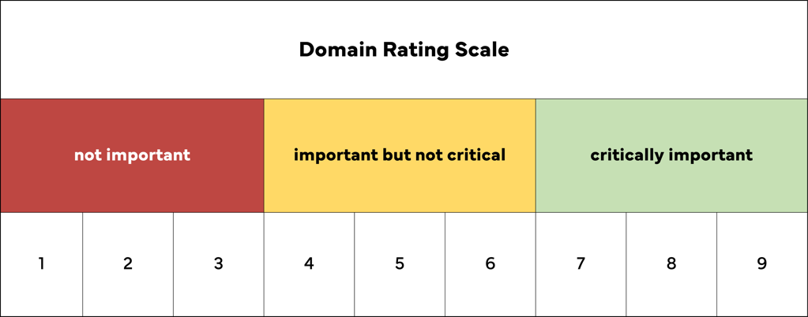

Comment fields should be made available after each domain to allow respondents to add additional notes about their decisions. At the end of the list of candidate domains, the respondents will have a chance to nominate additional domains they felt were omitted.

**Round 4:** Due to the likelihood of multiple domains meeting the consensus threshold in earlier rounds, OMERACT includes a fourth round to help working groups finalize and prioritize the list of domains. This round addresses situations where many domains are initially rated as critically important.

***Constructing Delphi Survey – Feedback & Non-Responder Management***

After each round, participants receive feedback summarizing responses from their collaborator group and the overall group, highlighting areas of agreement, disagreement, and shifts in ratings. This feedback allows participants to reconsider their views and adjust their ratings in subsequent rounds based on the collective input. Working groups should establish clear guidelines on managing non-responders, deciding whether they will be excluded from future rounds or allowed to continue, ensuring consistency and transparency. After applying reminder strategies, non-responders from earlier rounds will be excluded from further participation, while partial responders will be tracked in the data.

\*\*\**OMERACT suggests including a reference for these decisions.*

***Constructing Delphi Survey – Pilot Testing***

Once the Delphi protocol, including the page content and domain definition tracker, is complete, the working group steering committee will review and test the survey in their chosen platform. Adjustments will be made, and a final survey link will be ready for the working groups to disseminate to the potential respondents identified in their recruitment strategy.

**RECRUITMENT**

***Recruitment – Representation***

Engaging various collaborators is essential for developing and implementing a Core Domain Set. The working group will use the framework below to engage various collaborators and representatives from at least **three** continents.

|  |  |  |
| --- | --- | --- |
| Collaborator Group | Description | Illustrative examples |
| *Patients:* | | |
| Patient research partners, patients and patient groups, caregivers | represents the perspective of those who are directly impacted by healthcare policies, practices, and outcomes. | People with disease, patient alliances, EULAR Standing Committee of People with Arthritis/Rheumatism in Europe |
| *Other Collaborators:* | | |
| Payers and purchasers of health services | Individuals, organizations, and entities that pay for health services. | Provincial/public health system plan, Health Maintenance Organization (HMO) Kaiser (HMO), private insurers |
| Payers/funders of research | Organizations or entities that fund health research programs or projects. | Canadian Institutes of Health Research (CIHR), National Institutes of Health (NIH) |
| Policymakers | This group represents the perspective of those who are responsible for establishing healthcare policies, regulations, and guidelines at the local, state, and national levels. | Australian Register of Therapeutic Goods (ARTG), US Food and Drug Administration (FDA), Health Canada, politicians |
| Principal investigators | represents the perspective of those who are directly involved in conducting healthcare research | Researchers and all members of the research team |
| Producers and commissioners of guidelines | Institutions and organizations that commission, develop, or implement guideline development procedures | National Institute for Health and Care Excellence, United Kingdom |
| Product makers such as pharmaceuticals, medical devices, and diagnostics | This group represents the perspective of those who are responsible for developing, testing, and marketing healthcare products. | Pharmaceutical companies, device makers |
| Program managers | Managers/directors/administrators and individuals who plan, lead, oversee, or deliver any program that provides public health, community services, or clinical care. | Administrators at health facility. |
| Providers | includes healthcare providers directly involved in delivering care, as well as their professional associations. | Front-line health workers - clinicians, pharmacists, American College of Rheumatology (ACR), European League Against Rheumatism (EULAR) |
| Public | Communities or general members of the population or community |  |
| Publishers | Those involved in the knowledge translation of evidence syntheses | Peer-review editors, scientific publishers, science writers, Elsevier |

***Recruitment - Sample Size***

Oversampling will be done at baseline to allow for attrition of 50%. Since OMERACT recommends responses from 100 PRPs and 100 other collaborators by the end of the final round, we suggest groups start with about 400 potential participants (200 in each group).

***Recruitment – Strategy***

There are several ways to recruit participants for Delphi studies. Based on previous experience, OMERACT working groups are recommended to use the recruitment strategies below. Using the table, please indicate which strategy will be used for which collaborator group and provide either a link to the material or include it in (Appendix B).

|  |  |  |
| --- | --- | --- |
| **Recruitment Strategy** | **Collaborator Group (Patient Research Partners, Other Collaborators, Both)** | **Link to Materials** |
| Dedicated Section on Working Group Website |  |  |
| Promotional Video |  |  |
| Direct personalized contact |  |  |
| Indirect contact through mailing lists |  |  |
| Mass emailing |  |  |
| Other: ________________ |  |  |

*\*\*\*add additional rows as needed*

**Patient Research Partners:** In domain selection, people with lived experience of the disorder are key to understanding relevant domains. Their perspective will have equal weight to the decisions of the other collaborators described below in all decision-making. PRPs and patients in the community will be recruited based on the following inclusion and exclusion criteria.

* Inclusion criteria - Who is being recruited, and what are the criteria for selection? e.g. Men and women over the age of 18 with the diagnosis of **[XXX]**, from [*which geographic regions*], with [*what type and stage of disease*].
* Exclusion criteria – Which research participants are excluded from participation?
* Which linguistic groups will be recruited?

Once the survey link is ready, it’s important to identify who will receive the survey in advance. Creating a contact list of Patient Organizations for dissemination is also important.

|  |  |  |
| --- | --- | --- |
| *Name & Contact Name of Patient Organization* | *Contact Email* | *Continent (minimum 3 continents must be included)* |
|  |  |  |
|  |  |  |

*\*\*\*add additional rows as needed*

**Other collaborators:** The input of other collaborator groups will be required. These groups include the following: Payers and purchasers of health services, Payers/funders of research, Policymakers, Principal Investigators, Producers and commissioners of guidelines, Product Makers, Program managers, Providers, the Public, and Publishers*.*

*Names and emails should only be retained by the group. These groups should extend beyond the OMERACT working group and include a minimum of three continents and multiple (at least three) collaborator perspectives as deemed important for the body of work listed above.*

|  |  |  |  |
| --- | --- | --- | --- |
| *All Other Collaborator Groups i.e., Providers Individuals, Purchasers, Payers, Policy makers, Product makers, Principal investigators* | *Name & Contact Name of Organization (indicate if this contact represents a broader group)* | *Contact Email* | *Continent:*  *Minimum 3 continents must be included* |
|  |  |  |  |
|  |  |  |  |

*\*\*\*add additional rows as needed*

***Recruitment – Special Considerations (if social media is not being used, this section does not need to be completed)***

Social media use is increasingly common, and Delphi recruitment may rely on new technologies, such as social media networks, to inform potential participants about or recruit them to participate. Based on the NIH guidance regarding social media recruitment, the working group has addressed the 8-item list below.

|  |  |
| --- | --- |
| Item | Response |
| 1. Have I considered the full implications of privacy in this new and less-controlled environment? |  |
| 2. I need to carefully consider how my materials will be used. |  |
| 3. Have I controlled my informational data in a locked format? |  |
| 4. Have I made the contact for further information site protected for the privacy of interested individuals? |  |
| 5. Do I clearly understand that the interactive nature of social media escalates the speed of interaction, allowing for greater opportunities for errors in protecting private information? Have I planned to obviate those errors? |  |
| 6. Have I accounted for problems related to the portability and secure handling of information, including the encryption of all government laptops, the encryption of sensitive information during transport, including but not limited to transport across the network or on portable media, and the reporting of unintended breaches of sensitive personal information in the government’s possession? |  |
| 7. Have I included my complete strategy for use of the social media and my strategies for protection of privacy and strategies for informed consent explicitly in my proposal to the IRB? |  |
| 8. Have my team and I clearly understood the invasive nature of joining groups (i.e., support groups, disease groups, advocacy groups, etc.) for the purpose of recruitment? This can undermine the trust of government research and your IC. |  |

More detail about these questions is available in the [NIH Guidance Regarding Social Media Tools.](https://www.nih.gov/health-information/nih-clinical-research-trials-you/guidance-regarding-social-media-tools)

**CONDUCTING THE Delphi SURVEY**

***Conducting the Delphi Survey*** *-* ***Initial Soliciting Email***

When the survey is ready and activated, invitees will receive an email and be directed to the survey site to review the survey's purpose and register should they agree to participate. The e-mail will include the information from the Participant Information Sheet (Appendix C)

Once potential participants review the Participant Information Sheet and agree to participate, they will register on the survey site including their name, a valid email address, demographic, and background information. The completed registration form from the Delphi system should generate an anonymous Study ID that will be sent to the participant for login of future rounds. At that point, they will be directed to the survey for round 1. Delphi will use the email and anonymous username to link respondents to their previous responses when they move to subsequent rounds of the Delphi and for email reminders about the survey.

***Conducting the Delphi Survey*** *–* ***Rounds 1-3***

Round 1 will be opened and continue until the sample size is achieved in each collaborator group (PRPs, All Others). The working group reviews the results of Round 1 for consideration of responses, new items, and comments. The working group will work between rounds 1 and 2 to review all recommended domains and track decisions for inclusion and exclusion; this spreadsheet will include the list of items added and comments on items where there is agreement & disagreement (Appendix D). Domain labels or definitions can be revised to clarify based on these comments. Modifications and additions are made to the Delphi software, and the results are advanced for Round 2.

In Round 2, all domains will again be offered along with any newly nominated domains from Round 1. All domains will again be rated for their importance for inclusion. In this situation, the respondents will see their responses from Round 1 and the responses from the other collaborator groups. The working group will determine a schedule for system reminders and send reminders to participants. Groups will work to maintain participant engagement, considering the final desired sample size. The Delphi software will compile Round 2 results, and any domain that has reached a consensus on inclusion will move to Round 3. The working group will update the Delphi Round Review spreadsheet from Round 1 and make any updates to the Delphi before moving to Round 3.

In Round 3, the shorter list of domains that are still not yet at the point of consensus are re-evaluated by participants.

***Conducting the Delphi Survey*** *-* ***Final round***

A final round is recommended to gather all domains that have reached a consensus and include them in a CDS for final comment. In this final round, the respondents will be able to select up to 10 domains and upon selection of their choice, they will be asked to offer comments on why this domain should or should not, in their opinion, be included. Domains where consensus was to exclude or those without consensus (no group voting > 70% to include or exclude) will not be offered in the final round.

***Conducting the Delphi Survey*** *-* ***Analysis***

Once all four rounds of the Delphi are complete, the feedback, along with the results of all three rounds of the Delphi process, will be reviewed by the Working Group. The Working Group will use the results and comments to make their final evidence-based decisions on the content of each layer of the OMERACT Onion, resulting in a draft OMERACT Core Domain Set. The draft Core Domain Set will be presented to the OMERACT Community for endorsement.

**ETHICAL CONSIDERATIONS**

We consider this protocol to be a minimal-risk protocol.

Efforts were made to create a de-identified process. Participants are invited to join the survey and are directed to register on the Delphi platform through the OMERACT mailing list, working group contacts, listservs, etc. These emails direct the potential participant to the survey website where the study is described, and if they agree, they will register their participation. Potential participants will register on the survey site and include their name and a valid email address. The Delphi should automatically generate an anonymous Study ID that will be sent to the participant. This information is kept from the research team. Data should be stored according to the guidelines of the institution where ethics approvals were obtained and only used for re-contacting the registered participants for the subsequent round of the Delphi survey and for the ability to show them their previous responses in each round of the Delphi process. The information is not used for any other purposes and is not accessed by the working group. Six months after the survey has been completed, emails and Study IDs will be removed from the database and securely deleted.

**Table 2:** Timetable of events for this proposed study.

|  |  |  |
| --- | --- | --- |
| Date | **Activity** | **Outcome** |
|  | Development of protocol and Delphi survey | Completed survey development |
|  | Submit and revise proposal and ethics documents | Obtained ethics approval |
|  | Recruitment streams and data collection Delphi Round 1 | Data collection completed for Delphi Round 1 |
|  | Submission and data collection Delphi Round 2 | Data collection completed for Delphi Round 2 |
|  | Submission and data collection Delphi Round 3 | Data collection completed for Delphi Round 3 |
|  | Submission and Data collection for Final rating | Data collection completed for final rating |
|  | Data analysis of respondent’s answers and preparation of written report. | Preparation of supporting documents for OMERACT |

**APPENDIX A - Domain Development Tracker -** [**Template**](https://omeract.org/wp-content/uploads/2024/05/Domain-Development-Tracker.xlsx)

**APPENDIX B – Participant Information Sheet -** [**Template**](https://omeract.org/wp-content/uploads/2025/03/OMERACT-Participant-Information-Sheet-Template-Oct-2024.docx)

**APPENDIX C – Demographic Questions -** [**Template**](https://omeract.org/wp-content/uploads/2025/03/OMERACT-Demographic-Questions-Template.docx)

**APPENDIX D – Delphi Round Review -** [**Template**](https://omeract.org/wp-content/uploads/2024/11/Delphi_Round_Review.xlsx)

**APPENDIX E – Delphi suggested Page Content -** [**Template**](https://omeract.org/wp-content/uploads/2025/03/Page-Content-Delphi_Oct-2024.docx)

**APPENDIX F – OMERACT Delphi Checklist -** [**Template**](https://omeract.org/wp-content/uploads/2025/03/OMERACT-Delphi-Checklist.xlsx)

**References**

Please add relevant references