OMERACT XXX Working Group Core Domain Sets Endorsement

- OMERACT Newsletter Announcement:
Members of the OMERACT community are invited to participate in the endorsement of the OMERACT XXX Core Domain Set.
After several years of diligent work, the OMERACT XXX Working Group is seeking endorsement of their Core Domain Set for XXX. An e-module will be available for all OMERACT members starting XXX to facilitate this process. The Working Group will also host two Q&A sessions to address any questions and provide further insights:
DATES:
We strongly encourage participants to complete the OMERACT modules on An Overview of the OMERACT Pathway for Developing a Core Domain Set and Domains & Domain Definition Reports before (THE DATE THE MODULE GOES LIVE).
We look forward to your participation and valuable input!
- Module Content for Edits
  - Intro Page:
OMERACT XXX Working Group Core Domain Sets Development
This eLearning module is designed to help participants understand the OMERACT XXX Working Group's development of a Core Domain Set for XXX. The Working Group successfully completed all steps in the OMERACT pathway for Developing a Core Domain Set.
Let's Begin!
Click the "Start Course" button to begin.
  - Overview
Why Your Participation Matters:
Participation in this eLearning module is important to ensure that OMERACT's decisions are made confidently and based on engaged participants' insight. This process imparts information, understanding, and readiness among all members. Beyond a simple nod, your endorsement will prove your understanding and commitment to the goals of the XXX Working Group and OMERACT. The Group greatly appreciates your involvement.
This short video introduces the disease processes under study, highlights the process undertaken in shaping the Core Domain Set, and underscores the vital role of Patient Research Partners.
OVERVIEW VIDEO
  - Core Domain Set Development
Interactive Learning:
- This page is designed as an interactive image
- You'll find small numbers below each step of the OMERACT pathway to develop a Core Domain Set. Each small number is a link that you can click to uncover detailed information about specific aspects of the core domain set with additional pre-reading materials and videos.
- This format allows you to explore the content at your own pace, ensuring you fully understand each segment before moving on.

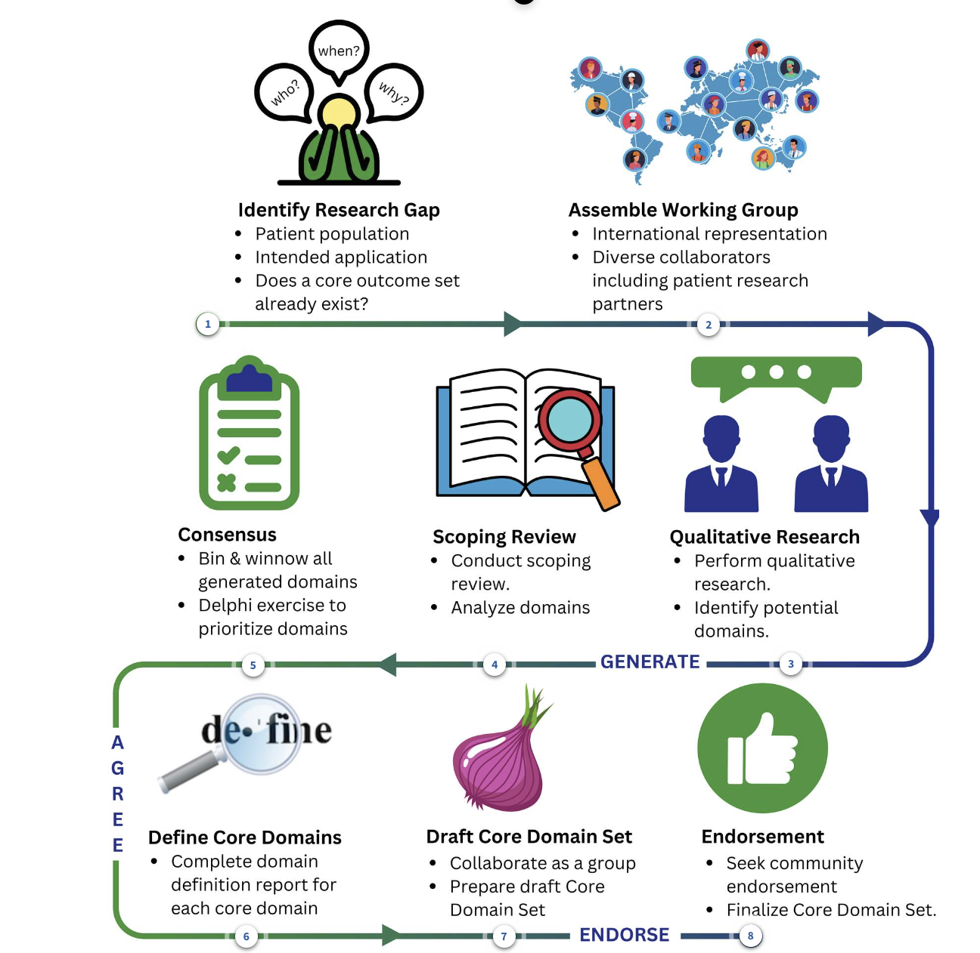
- Identify Research Gap

    - Assemble Working Group
The Working Group was formed following OMERACT guidance, including:
- 4 Co-chairs, representing a minimum of 3 continents.
- 2 Patient Research Partners
- 2 Fellows/Emerging Leaders and at least two other members with expertise or experience in the topic.

    - Qualitative Research
Please click on the links below to read the full publications. LINK TO RELEVANT PUBLICATIONS
Qualitative Work Overview Video
    - Scoping Reviews
Please click on the links below to read the full publications. LINK TO RELEVANT PUBLICATIONS
Scoping Reviews Overview Video
    - Consensus and Delphi Exercise
Please click on the links below to read the full publications. LINK TO RELEVANT PUBLICATIONS
Delphi Overview Audio Only
    - Domain Definitions
Add links for each domain definition report.
    - Draft Core Domain Set
OMERACT Onions
    - Endorsement
The OMERACT XXX Working Group, guided by the OMERACT pathway, addressed the research need to develop a Core Domain Set for XXX. They established a structured foundation through the PICOC framework, developed a Core Domain Set Development work plan, and conducted scoping reviews to identify key domains. The group prioritized candidate domains through a Delphi Survey, resulting in a Draft Core Domain Sets with detailed definitions.
The next step in their work is to seek the endorsement of the Core Domain Sets from the OMERACT community.
  - Next Steps
- Q&A Session
The Working Group will also host two Q&A sessions to address any questions and provide further insights to participants before completing their endorsement:
DATES
- Core Domain Sets Endorsement
The survey is embedded below for participants who feel confident in their understanding of all the materials and are ready to endorse the Core Domain Sets. If you wish to attend the Q&A sessions before voting, you can hit "Continue," the SurveyMonkey link will be shared with participants following each Q&A session.

- Endorsement Survey
* 1. Please select the collaborator group that best represents your affiliation or role in
relation to your involvement with OMERACT.
Patient research partners, patients/consumers, caregivers, and patient groups
Payers and purchasers of health services
Payers/funders of research
Policymakers
Principal investigators
Producers and commissioners of guidelines
Product makers
Program managers
Providers
Public
Publishers
Other (please specify)

* 2. What is your age?
18-29
29-39
40-49
50-59
60-69
70-79
80 and older
* 3. Which term(s) best describe your current gender? Select the option(s) that apply to you.
Agender
Bigender / Multigender
Gender-fluid
Gender Queer
Man
Nonbinary
Questioning
Transgender
Two-Spirit
Woman
I prefer not to answer
Other (please specify)
* 4. Please select the country in which you currently reside
WHO dropdown of countries
* 5. Based on the completion of this module, do you feel confident about your understanding
of the OMERACT XXX Working Groups development of a Core Domain Set for
XXX?
Yes, I feel confident.
No, I do not feel confident yet.
* 6. Do you endorse the core domain set as shown for XXX?
Yes, I endorse the core domain set.
No, I do not endorse the core domain set
  - Acknowledgments & Thank You
On behalf of OMERACT and the entire XXX Working Group, we would like to express our gratitude for your participation in the eLearning module and your endorsement of the Core Domain Sets.
We will continue to share updates and findings through the OMERACT newsletters and publications, keeping you informed about the latest developments in the field.

